**Buổi 1:** Thực hành cài đặt bWAPP và tấn công.

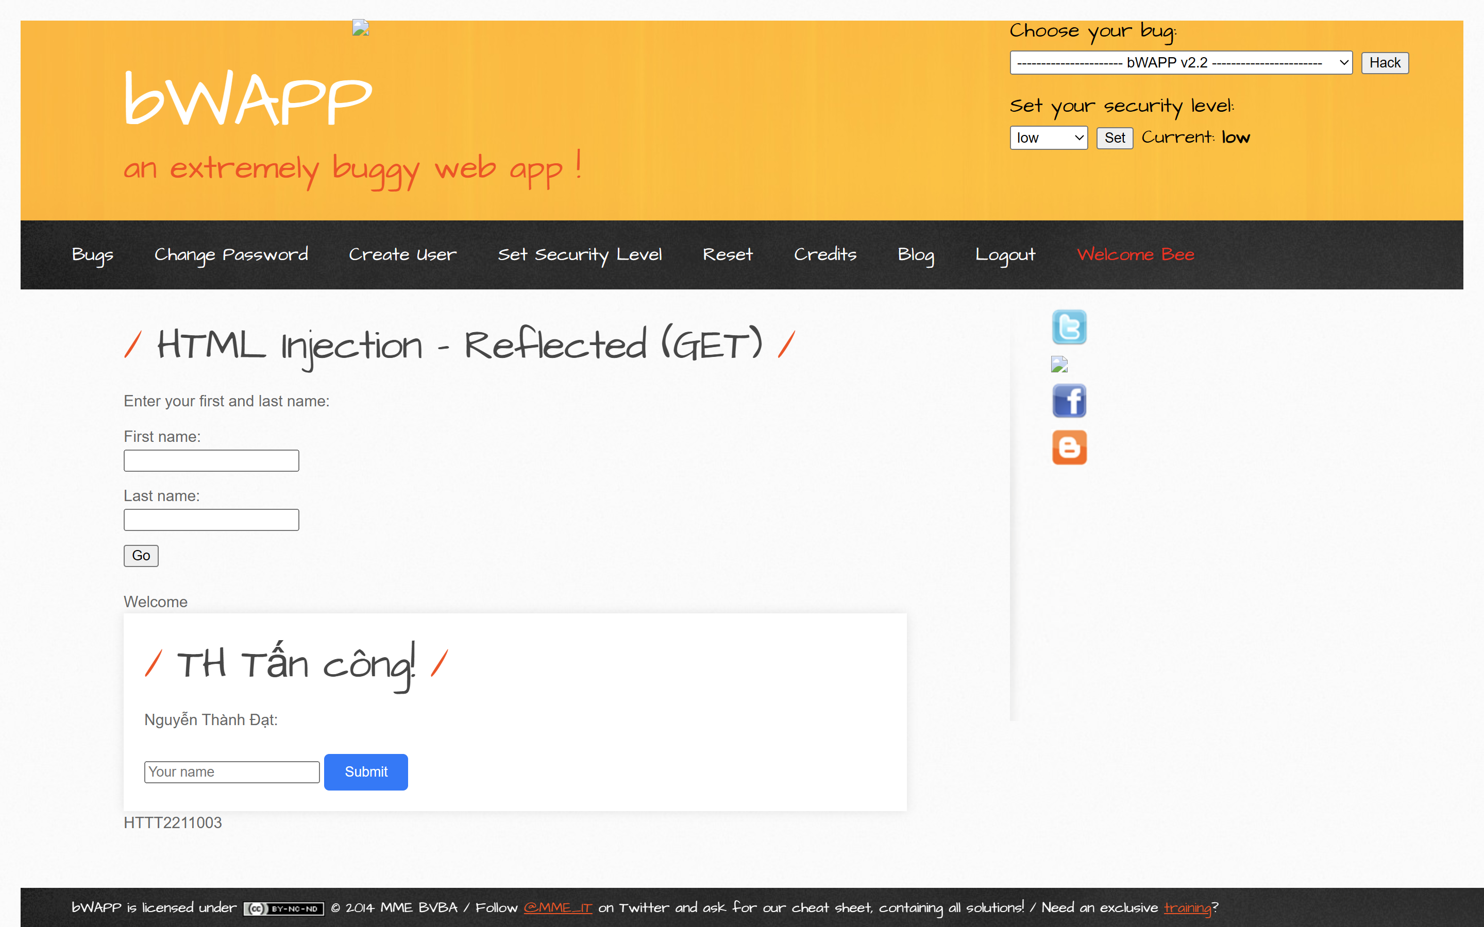

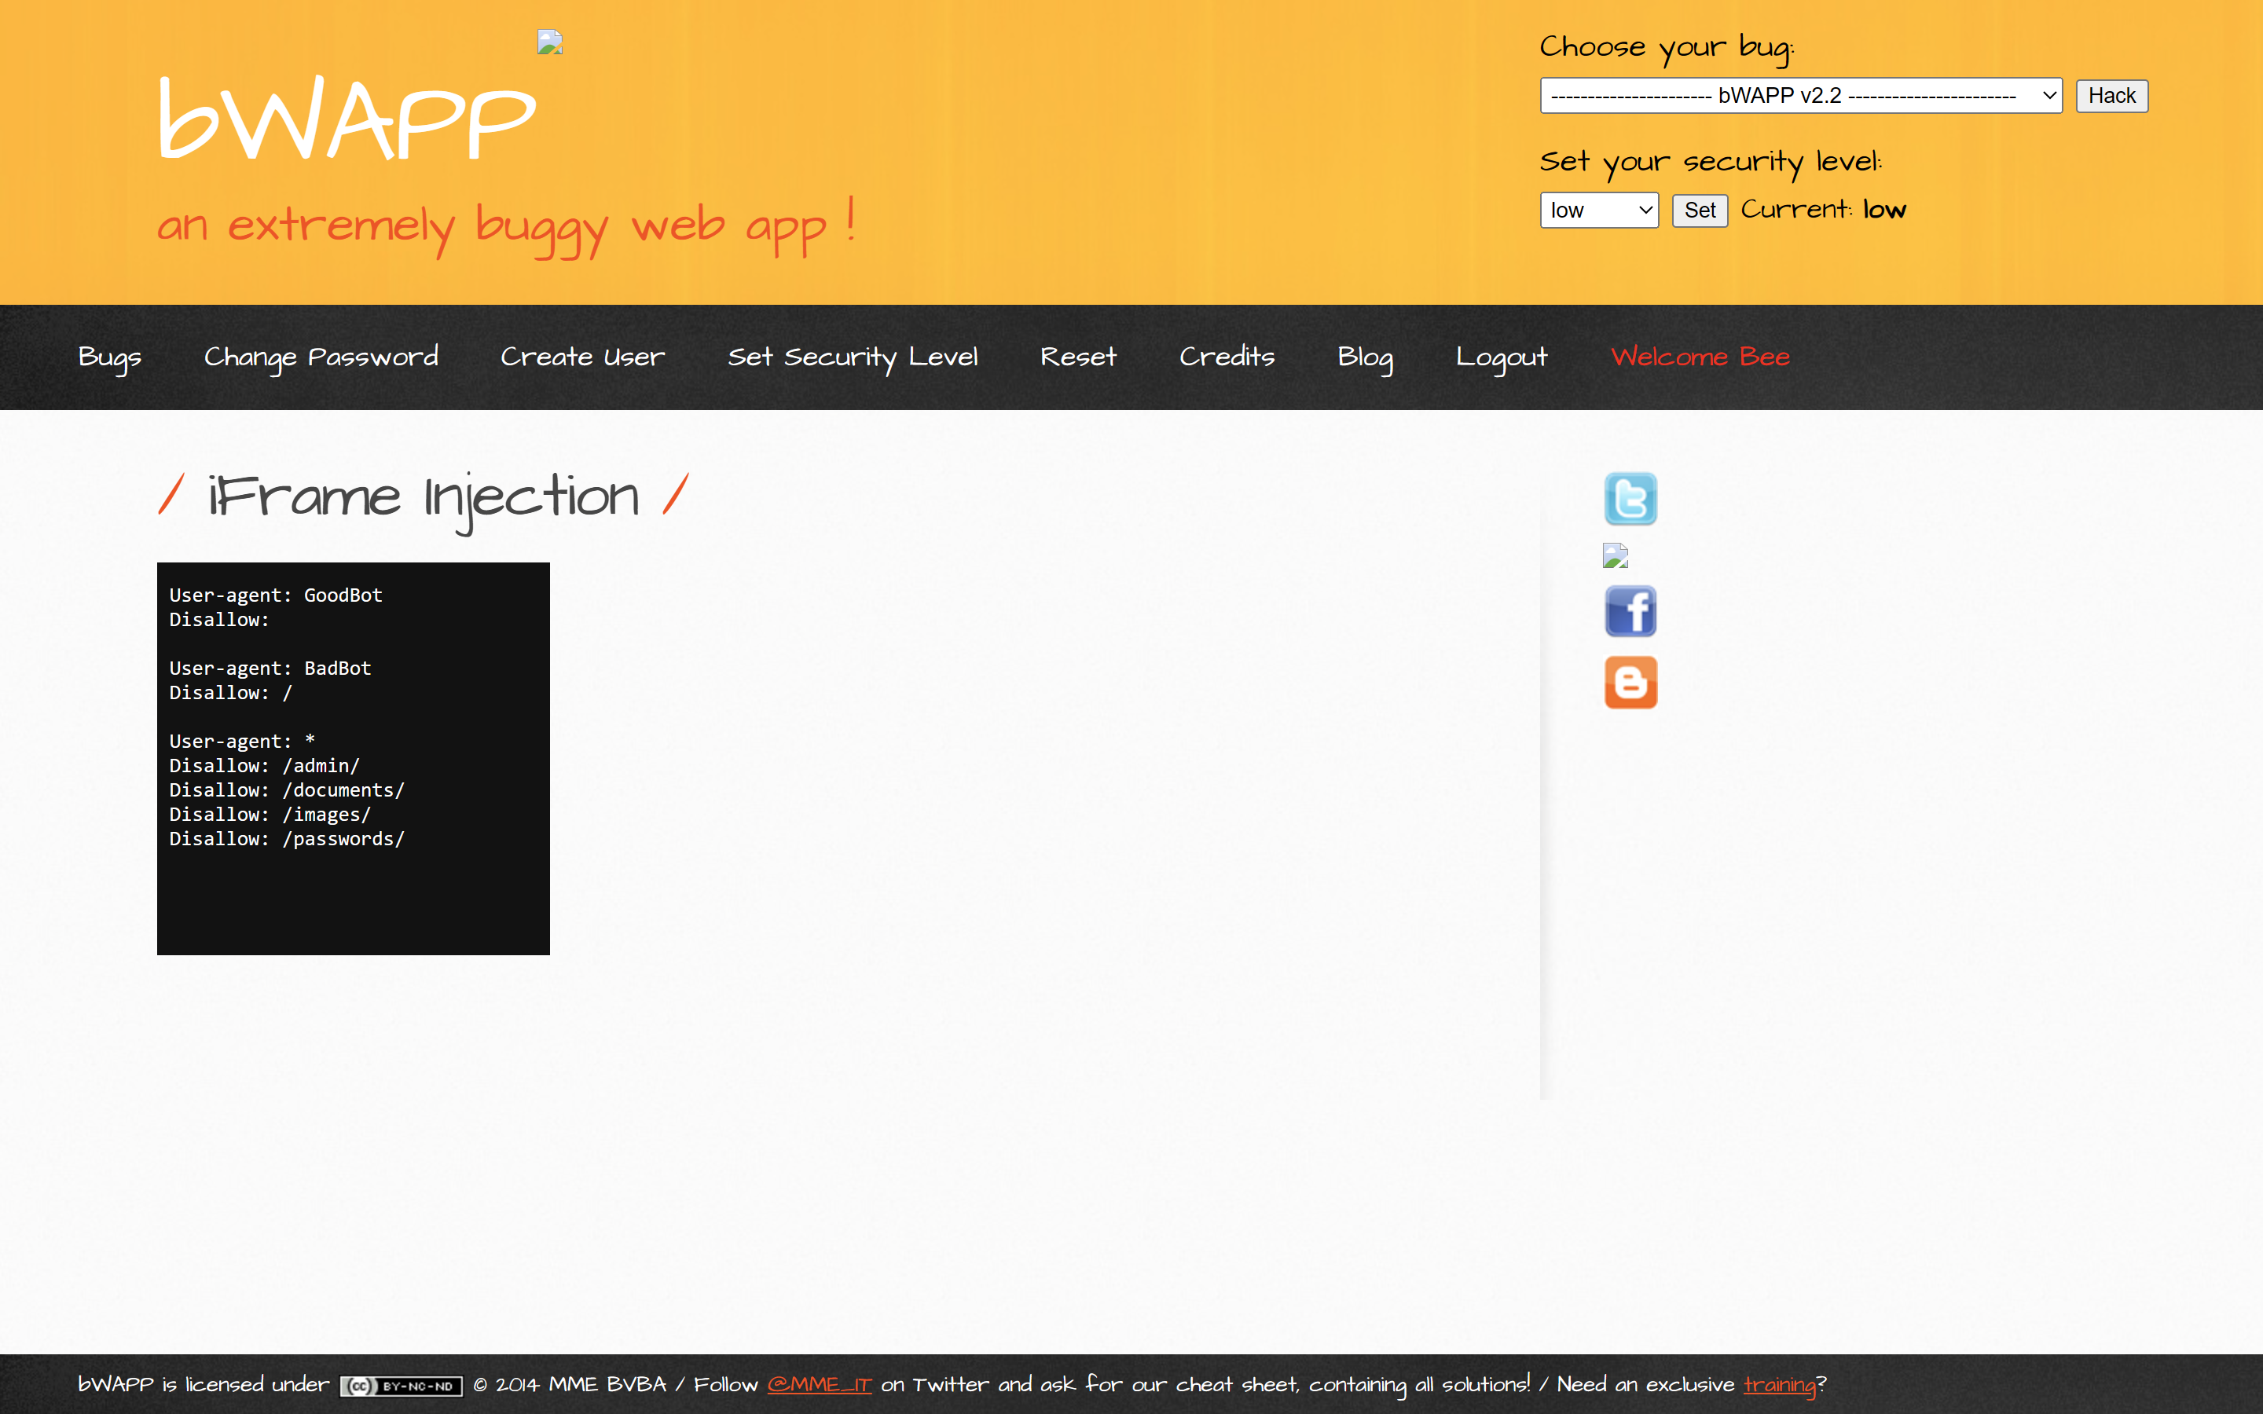



**Buổi 2:** 21/09/2024

**ISS Injection**

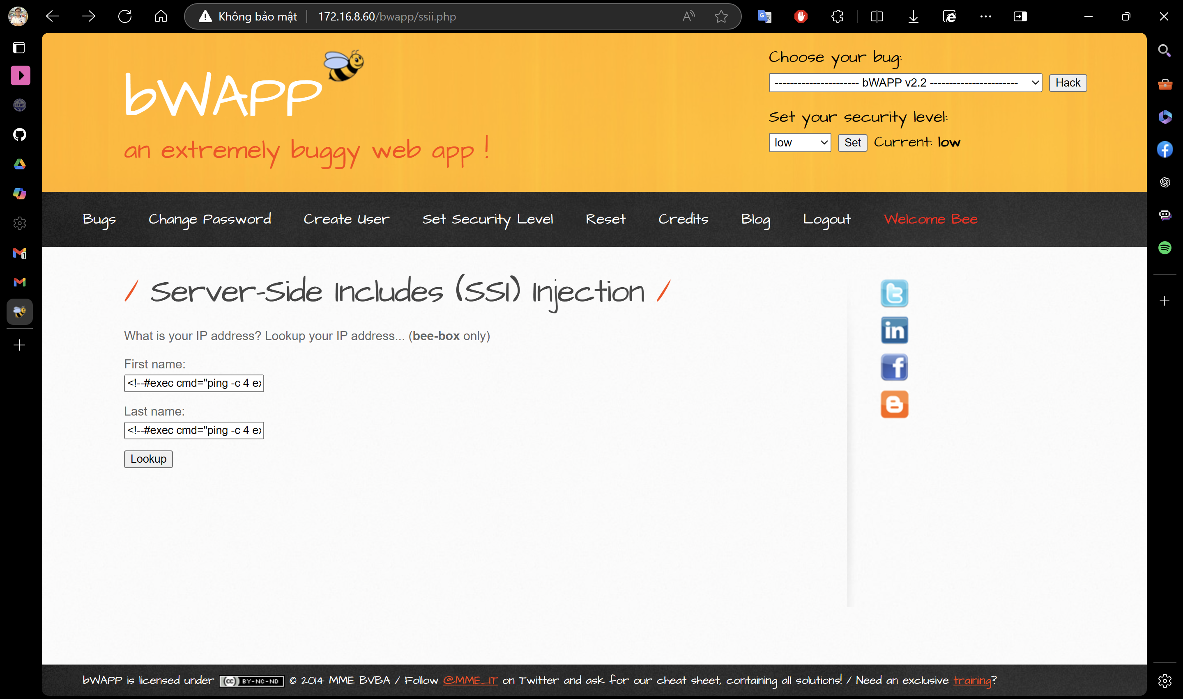

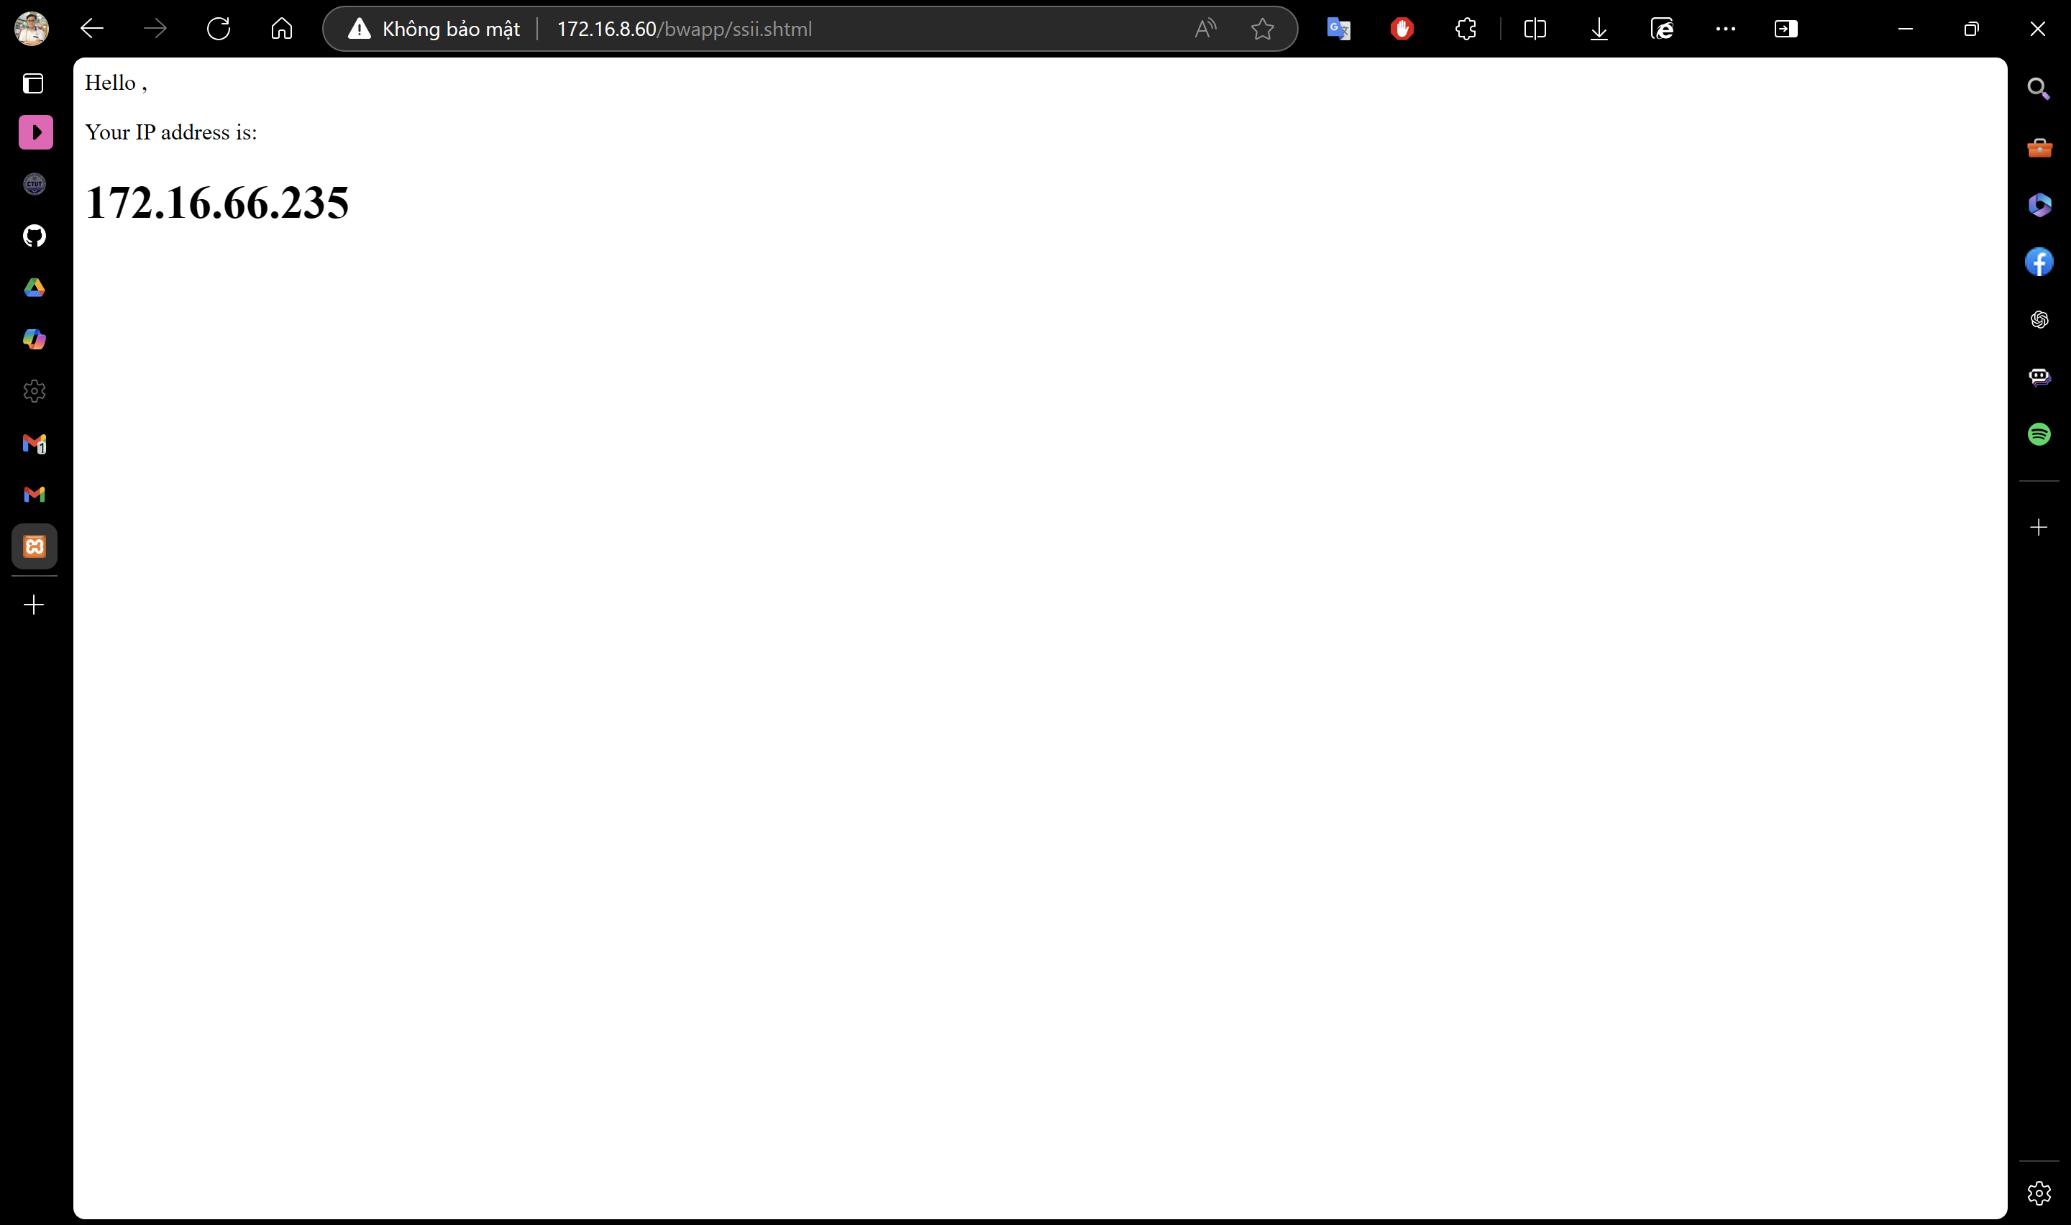

**XML/XPath Injection (Login Form)**

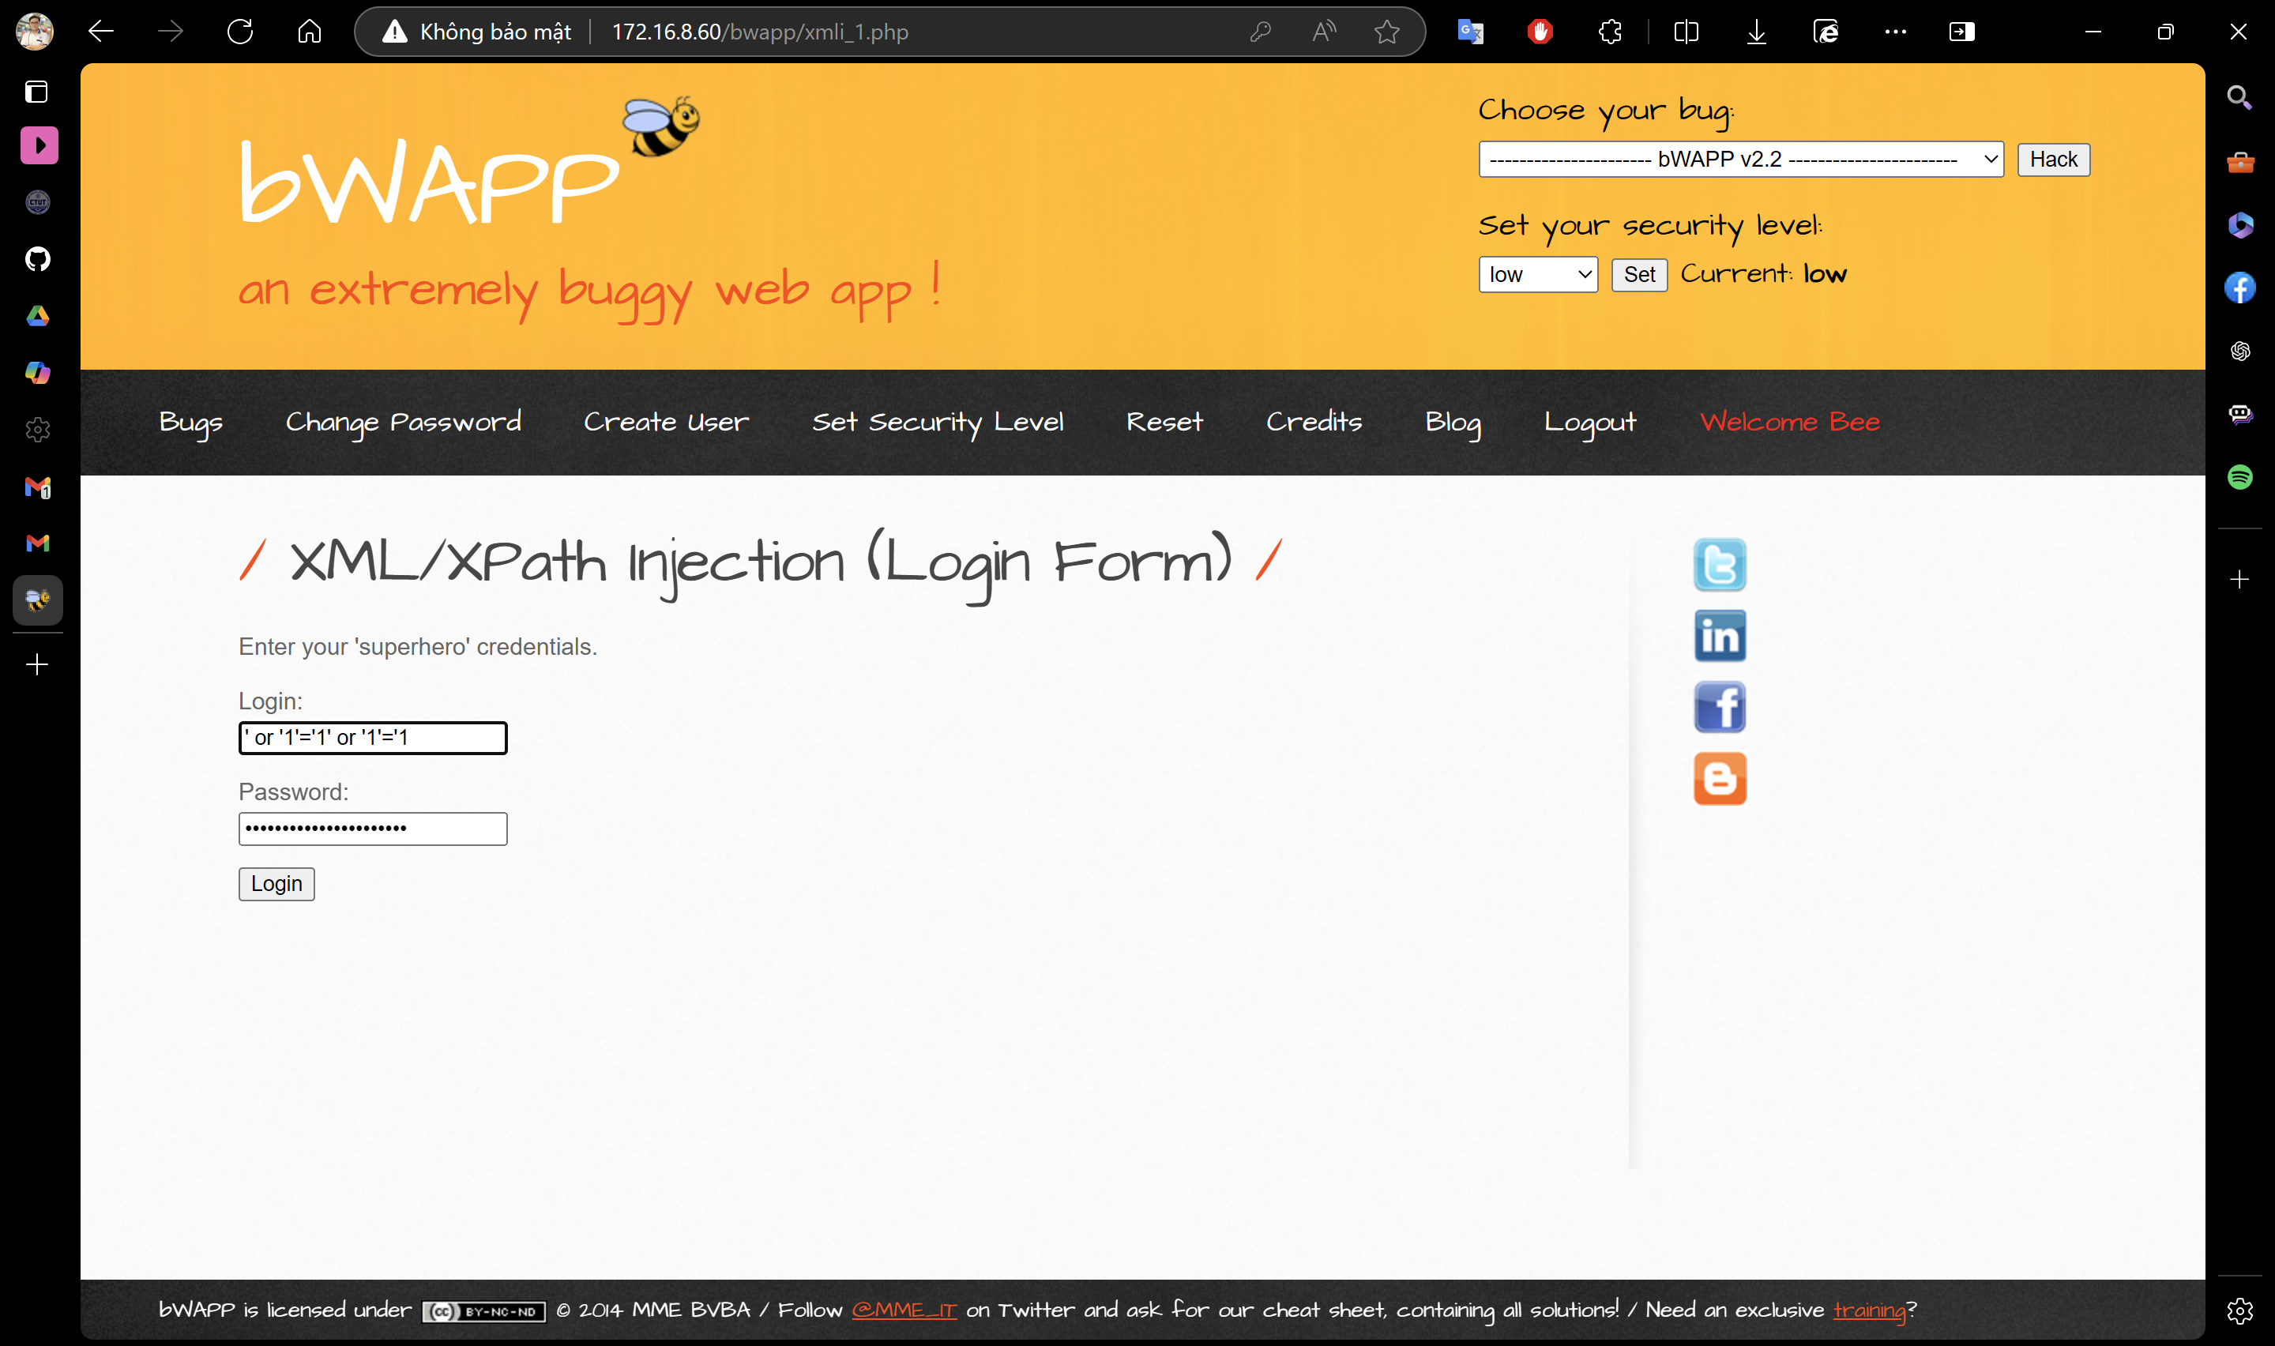

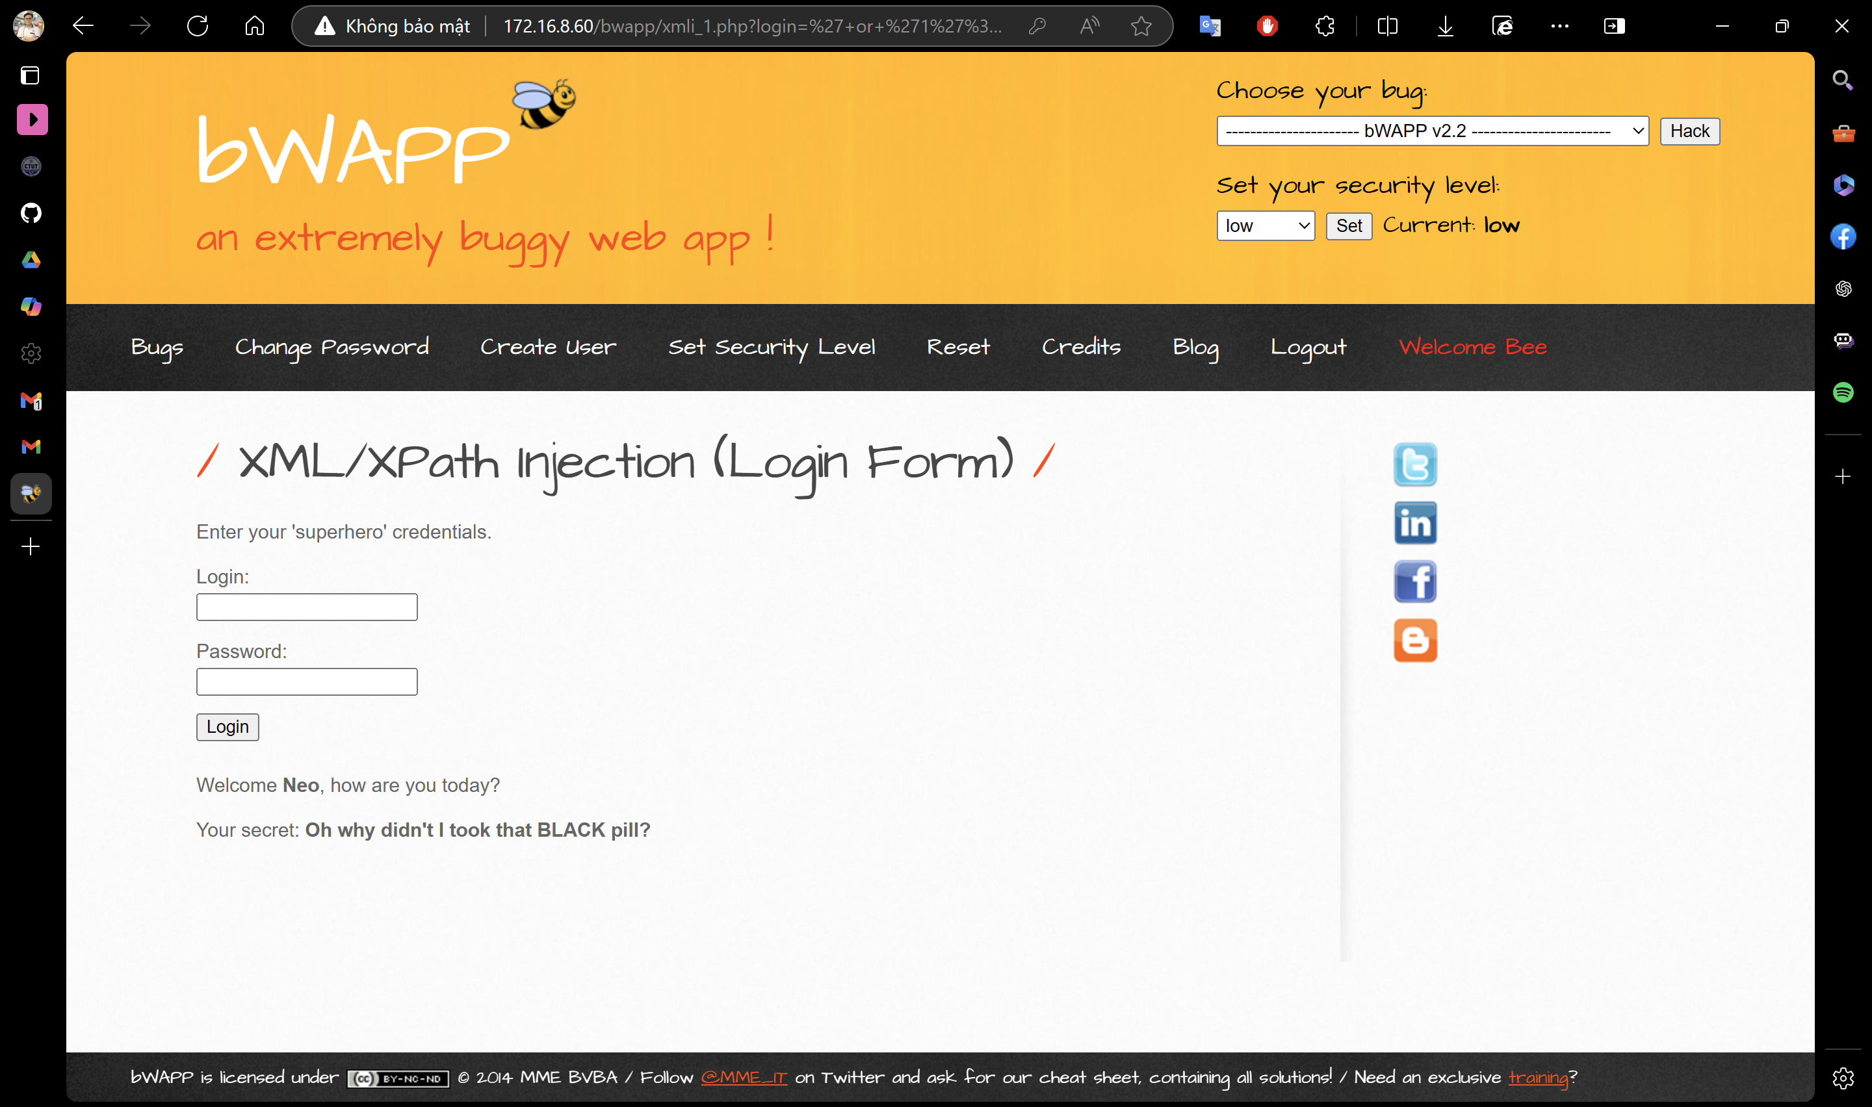

**XSS - Reflected (GET)**

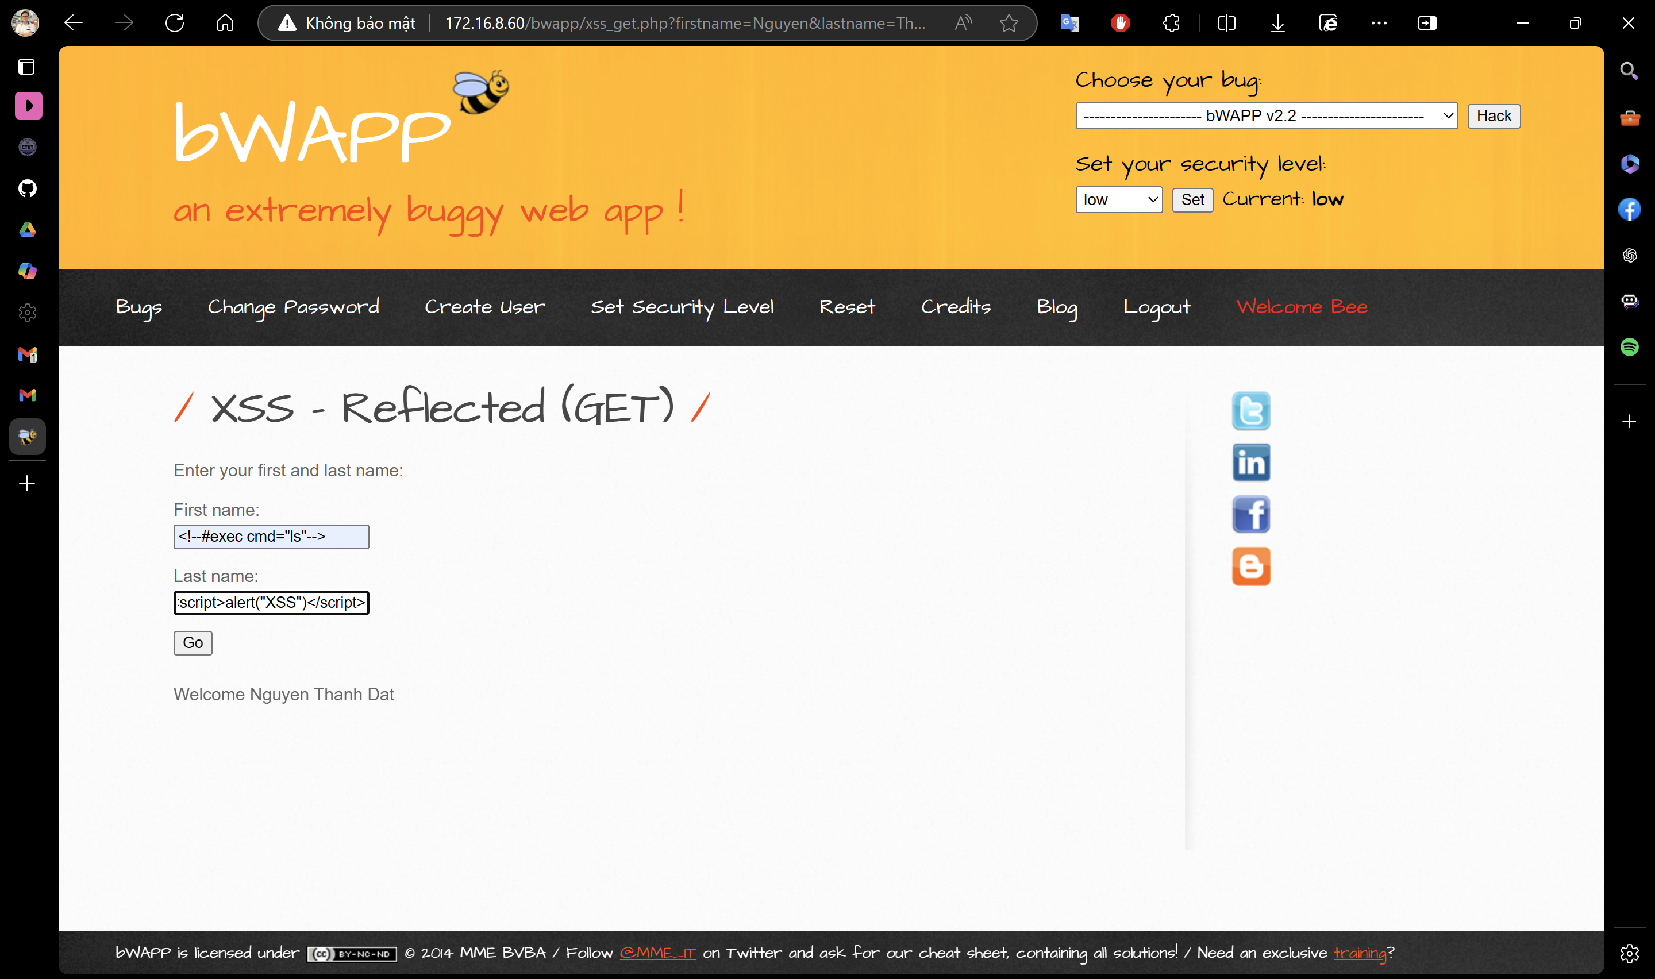

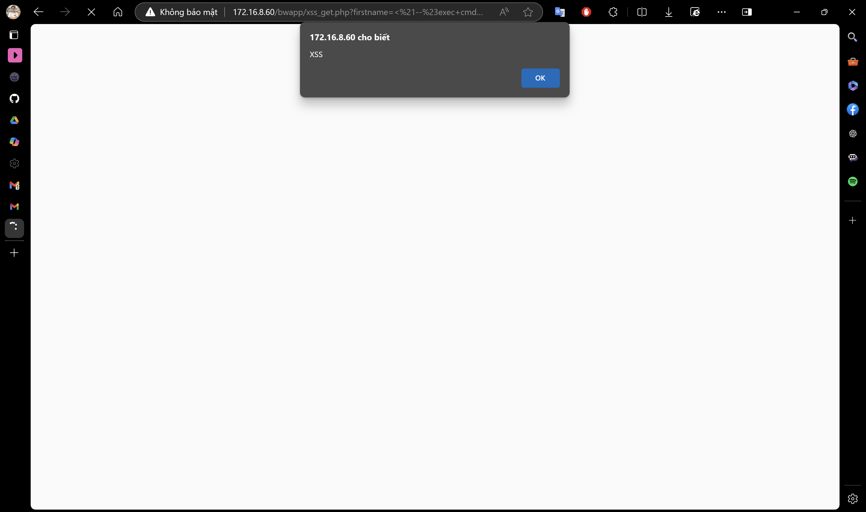

**Buổi 3:** 05/10/2024

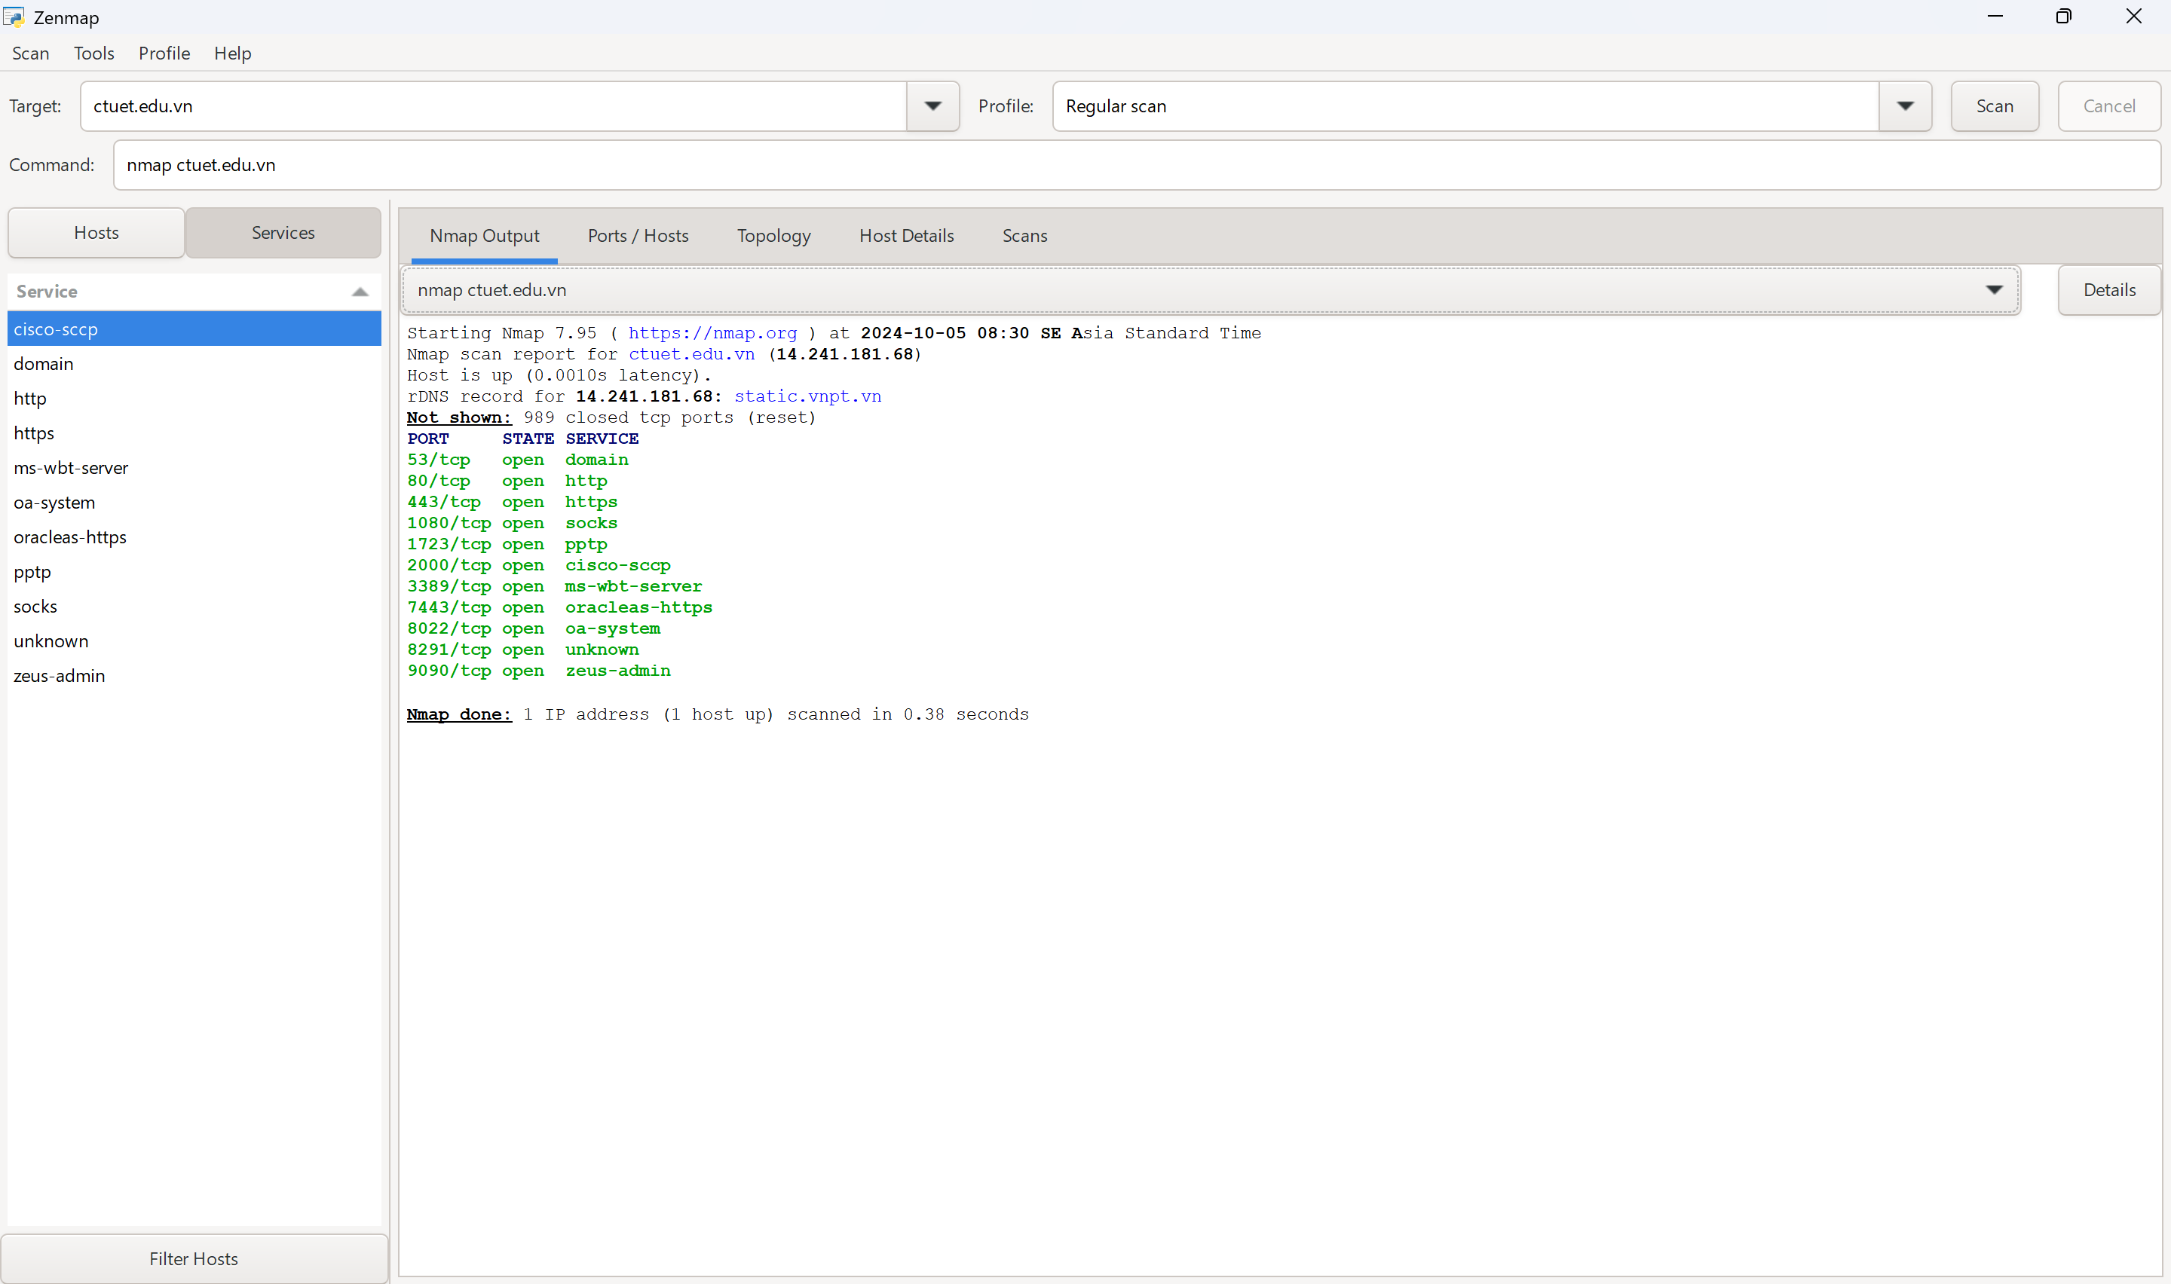

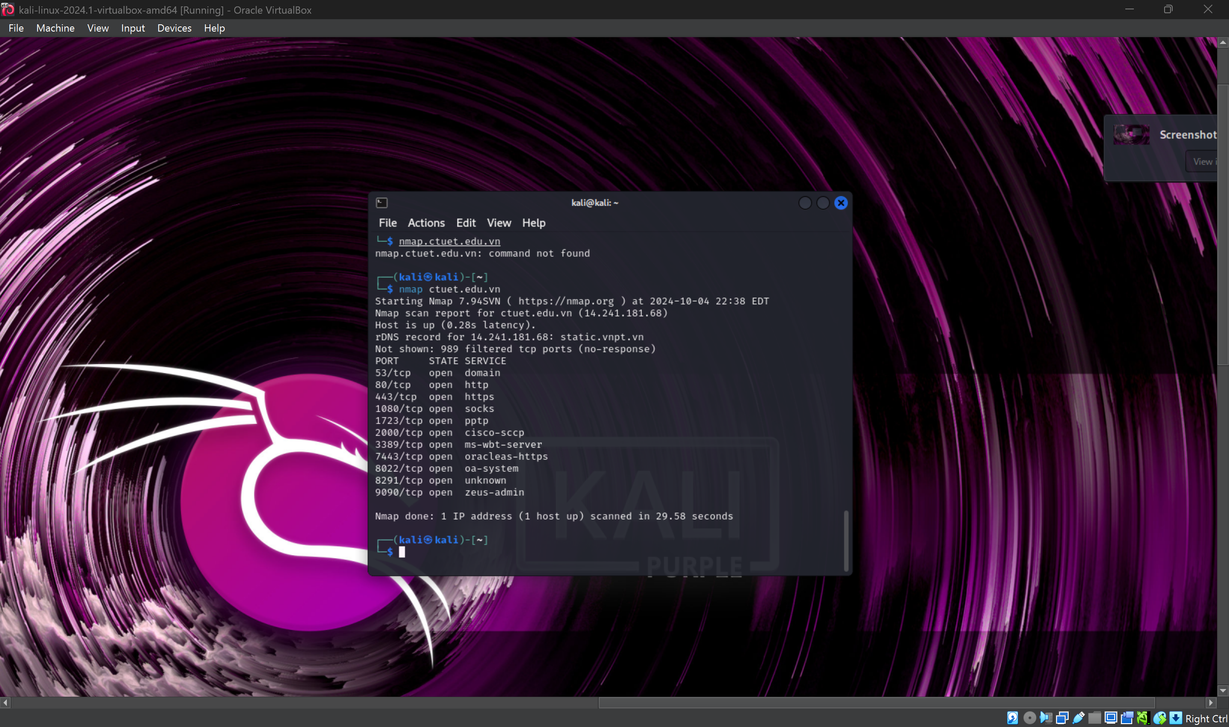

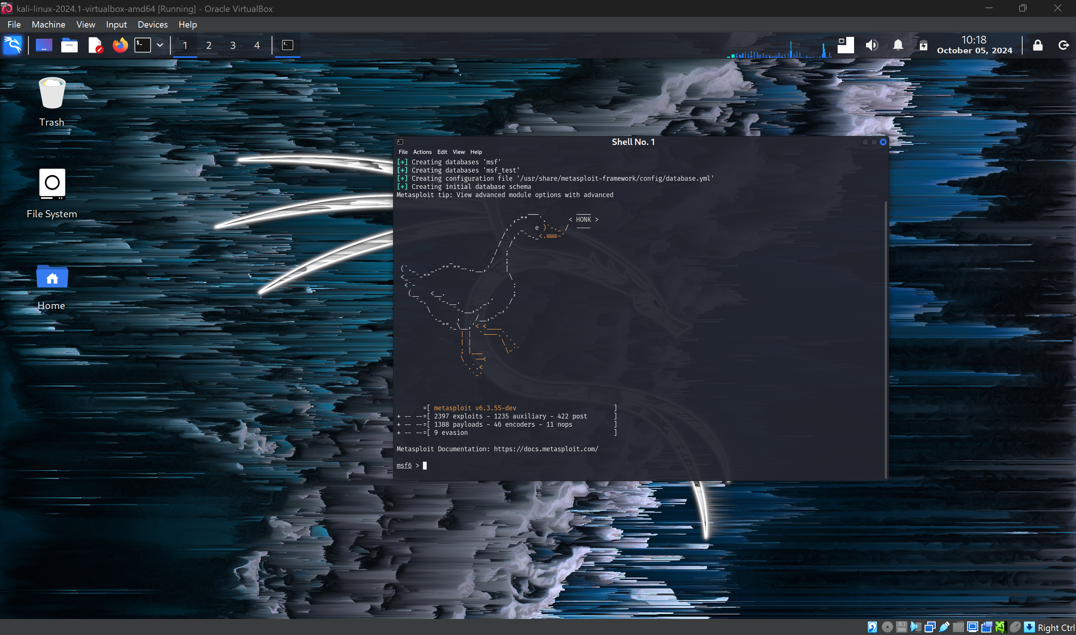

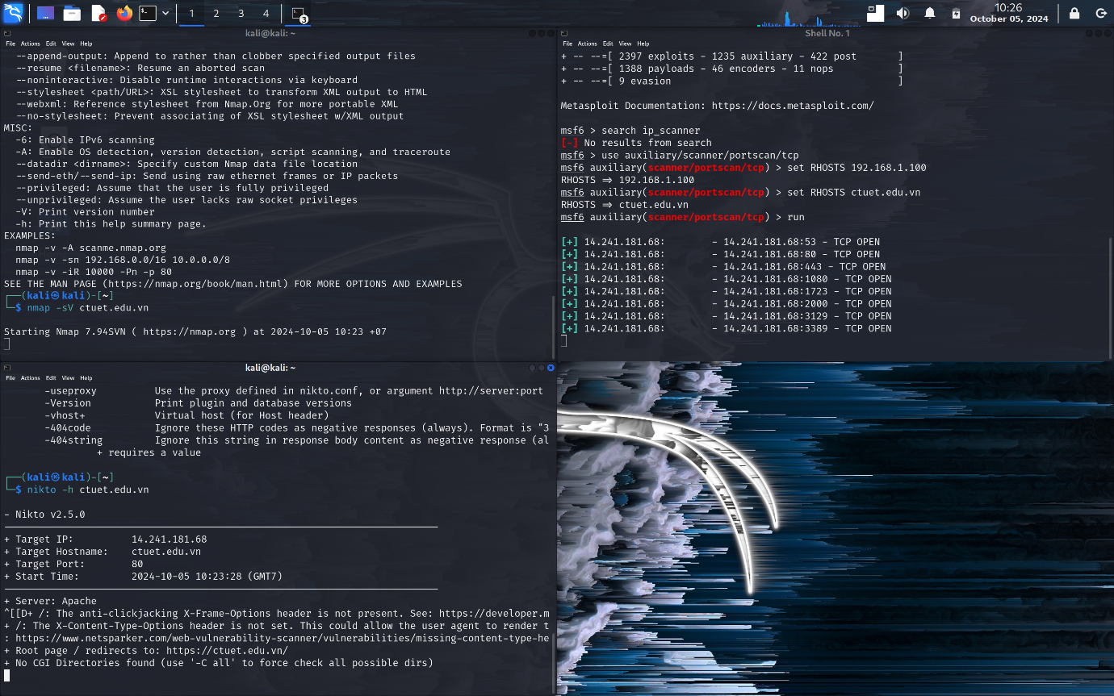

**Buổi 4:** 19/10/2024

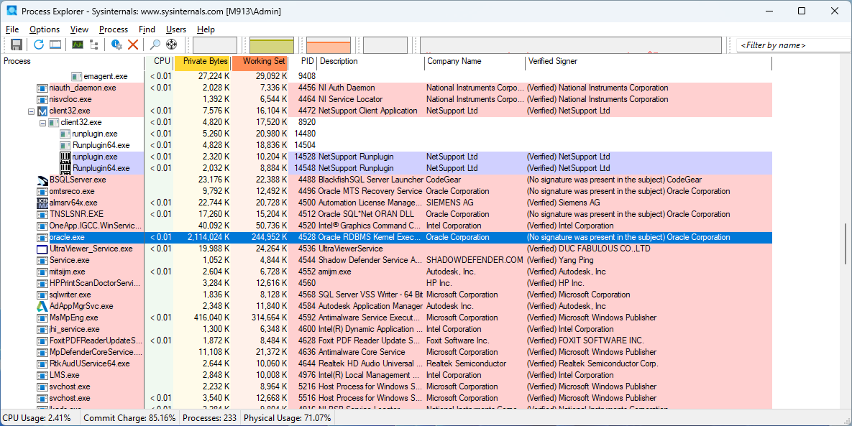

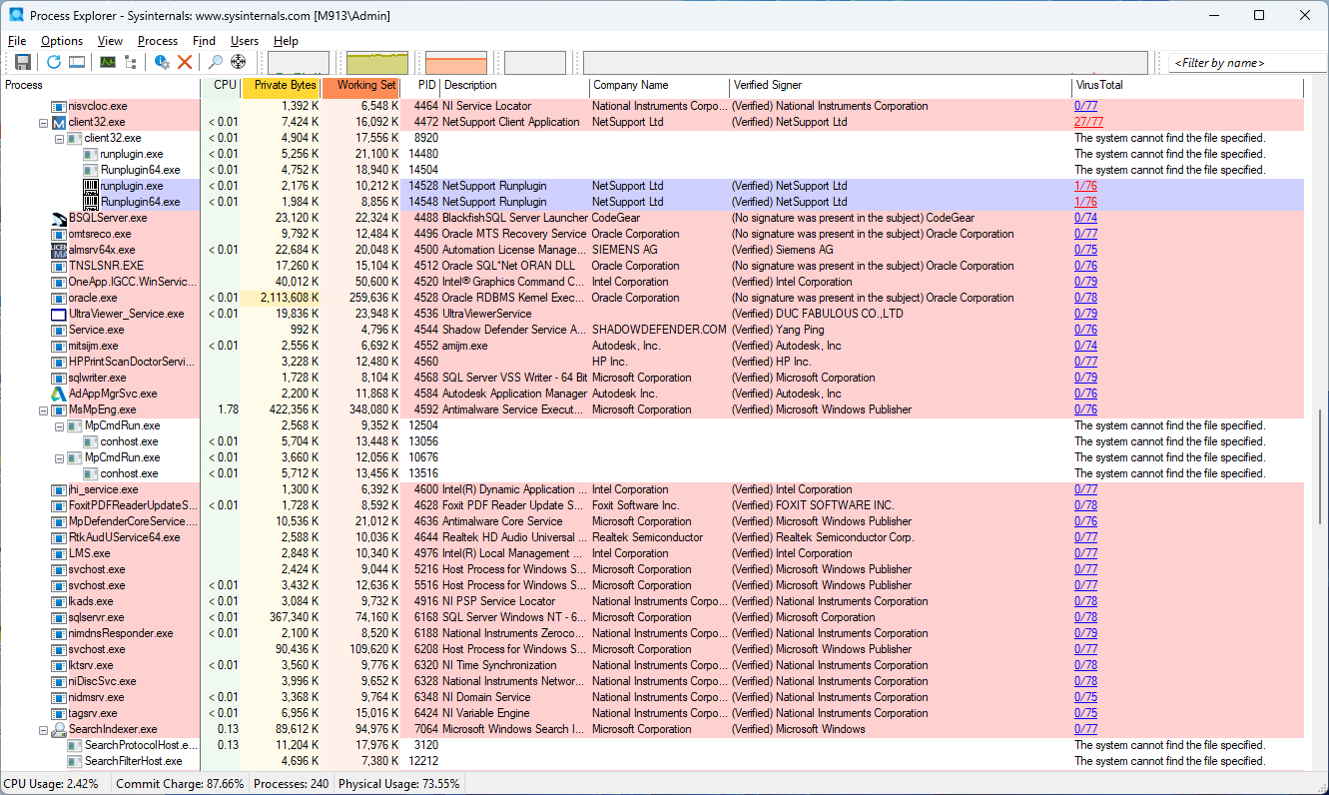

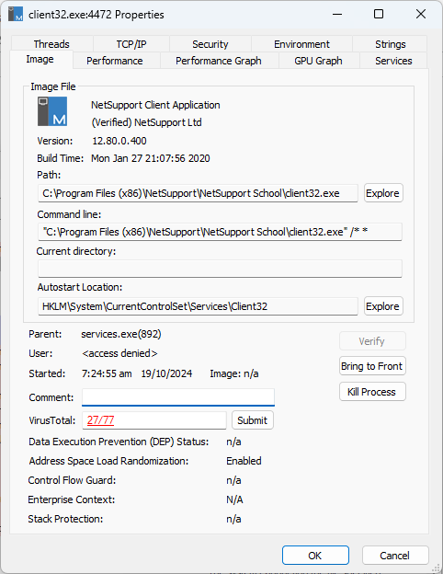

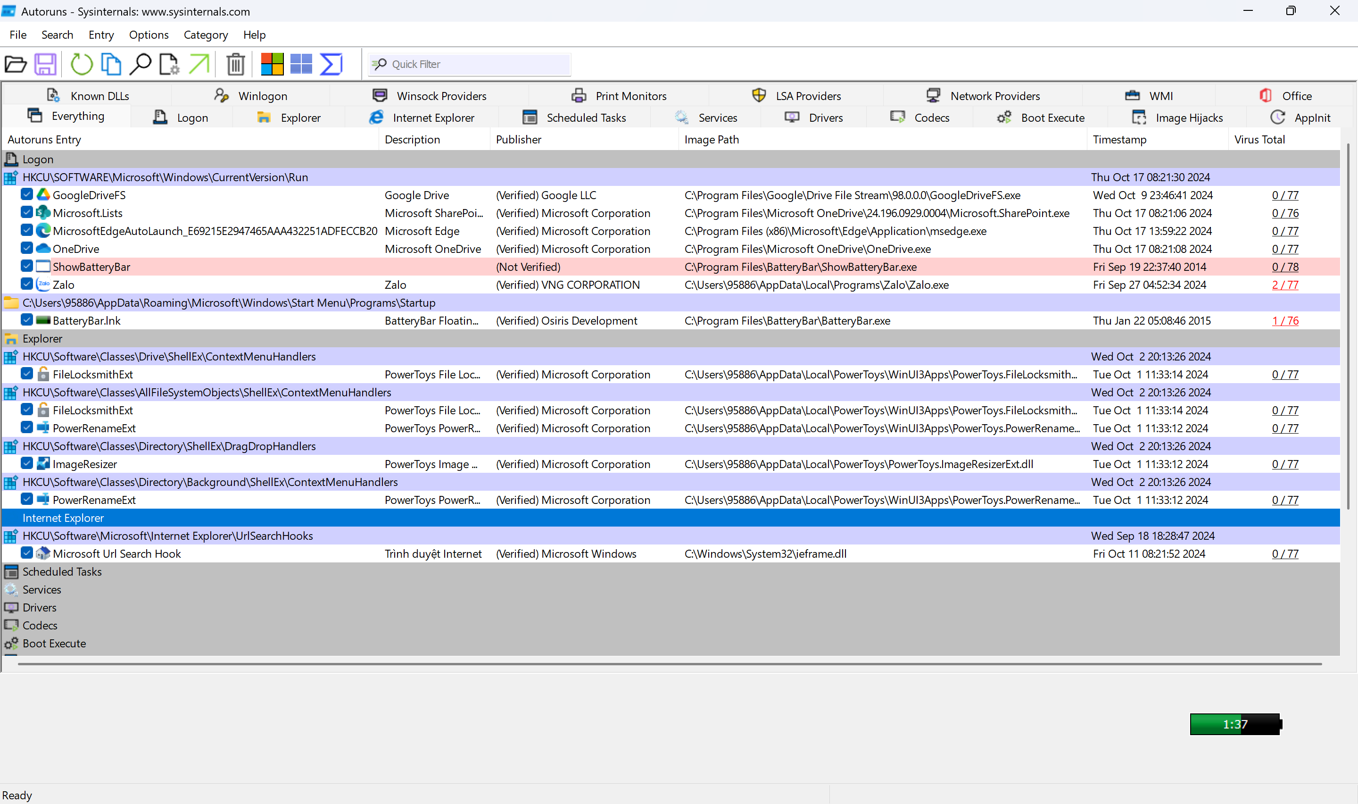

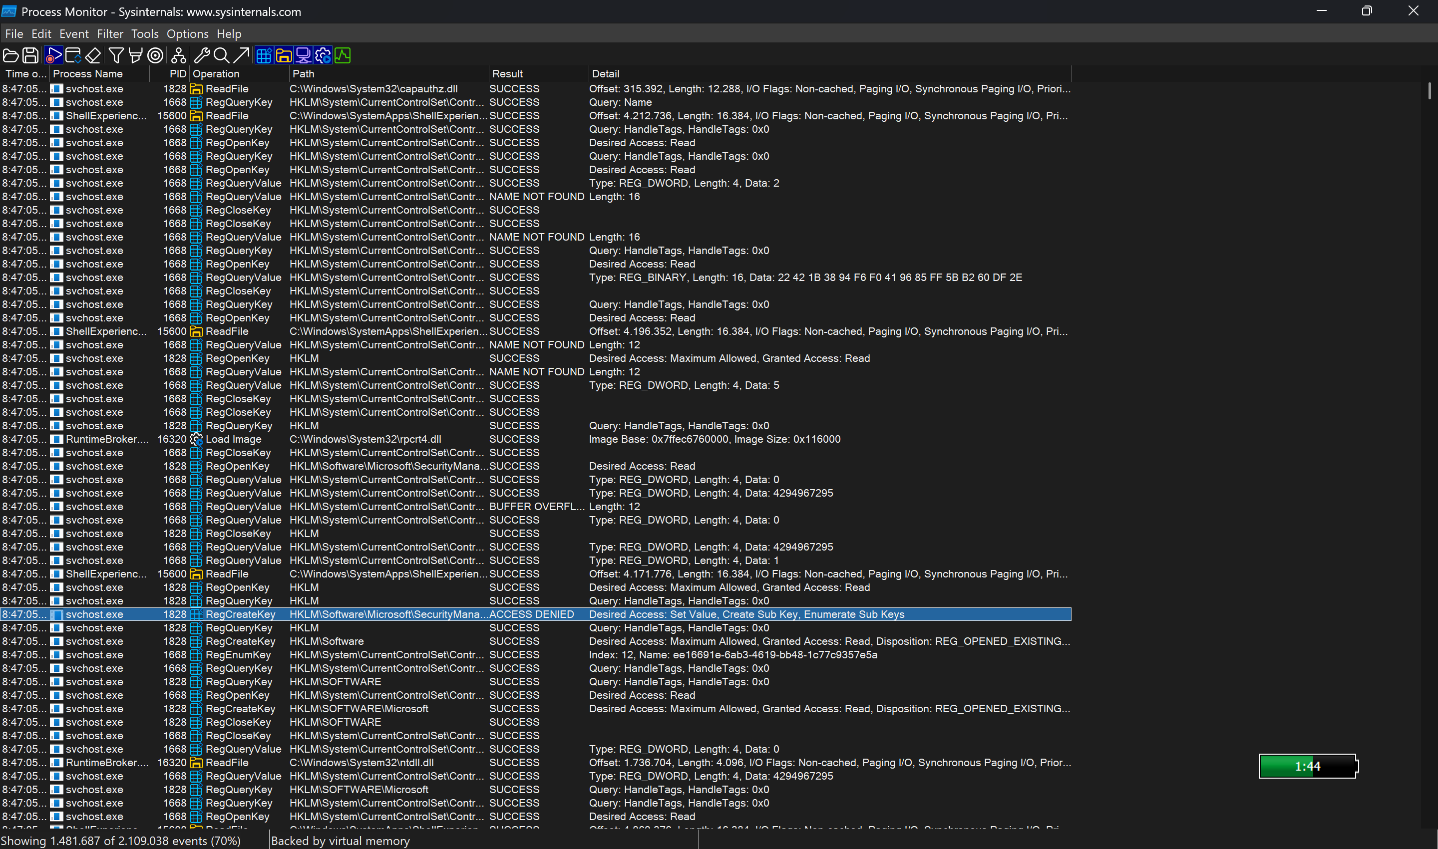

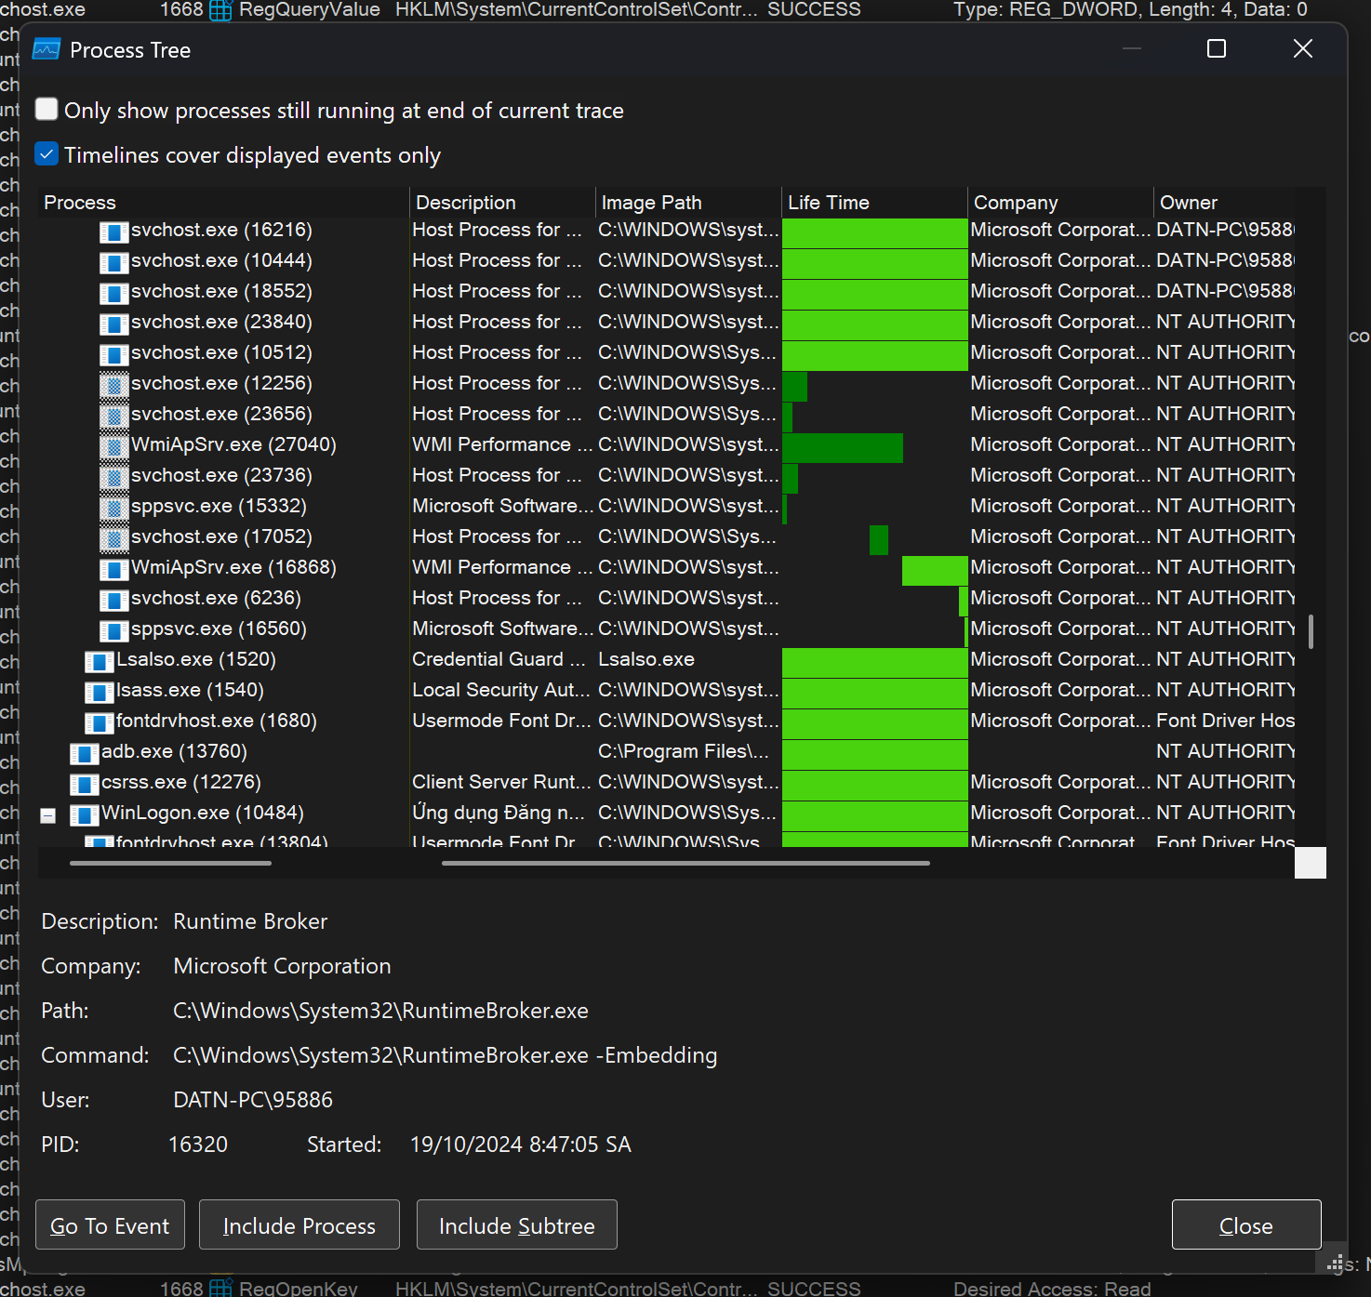

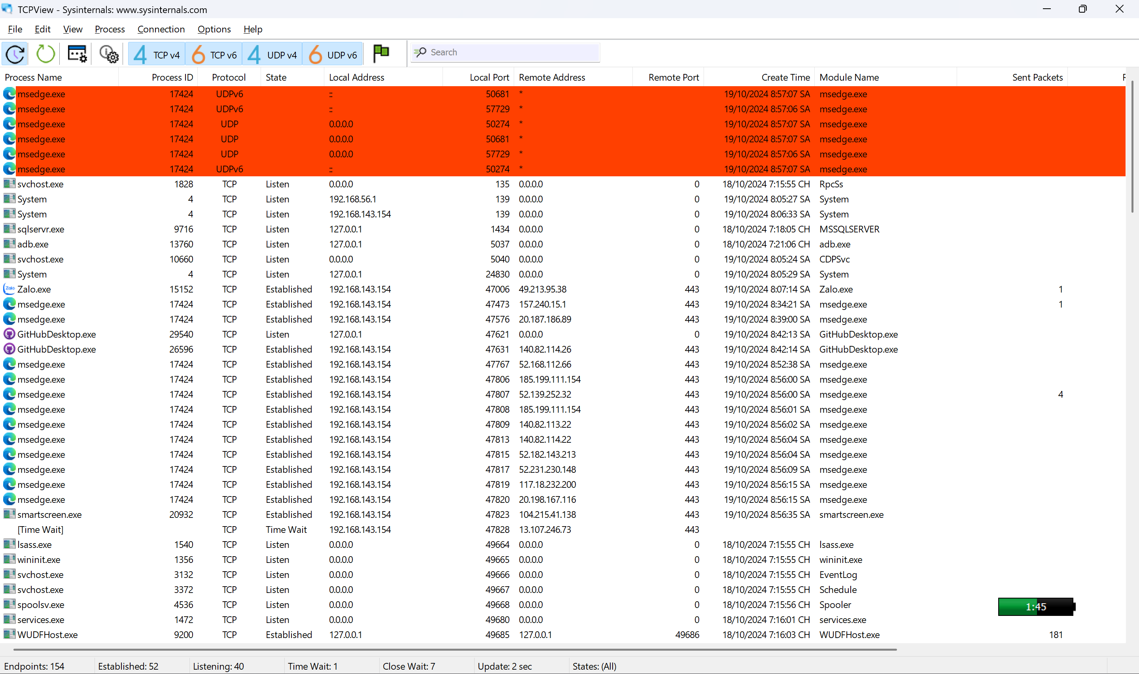

**Buổi 5:** 2/11/2024

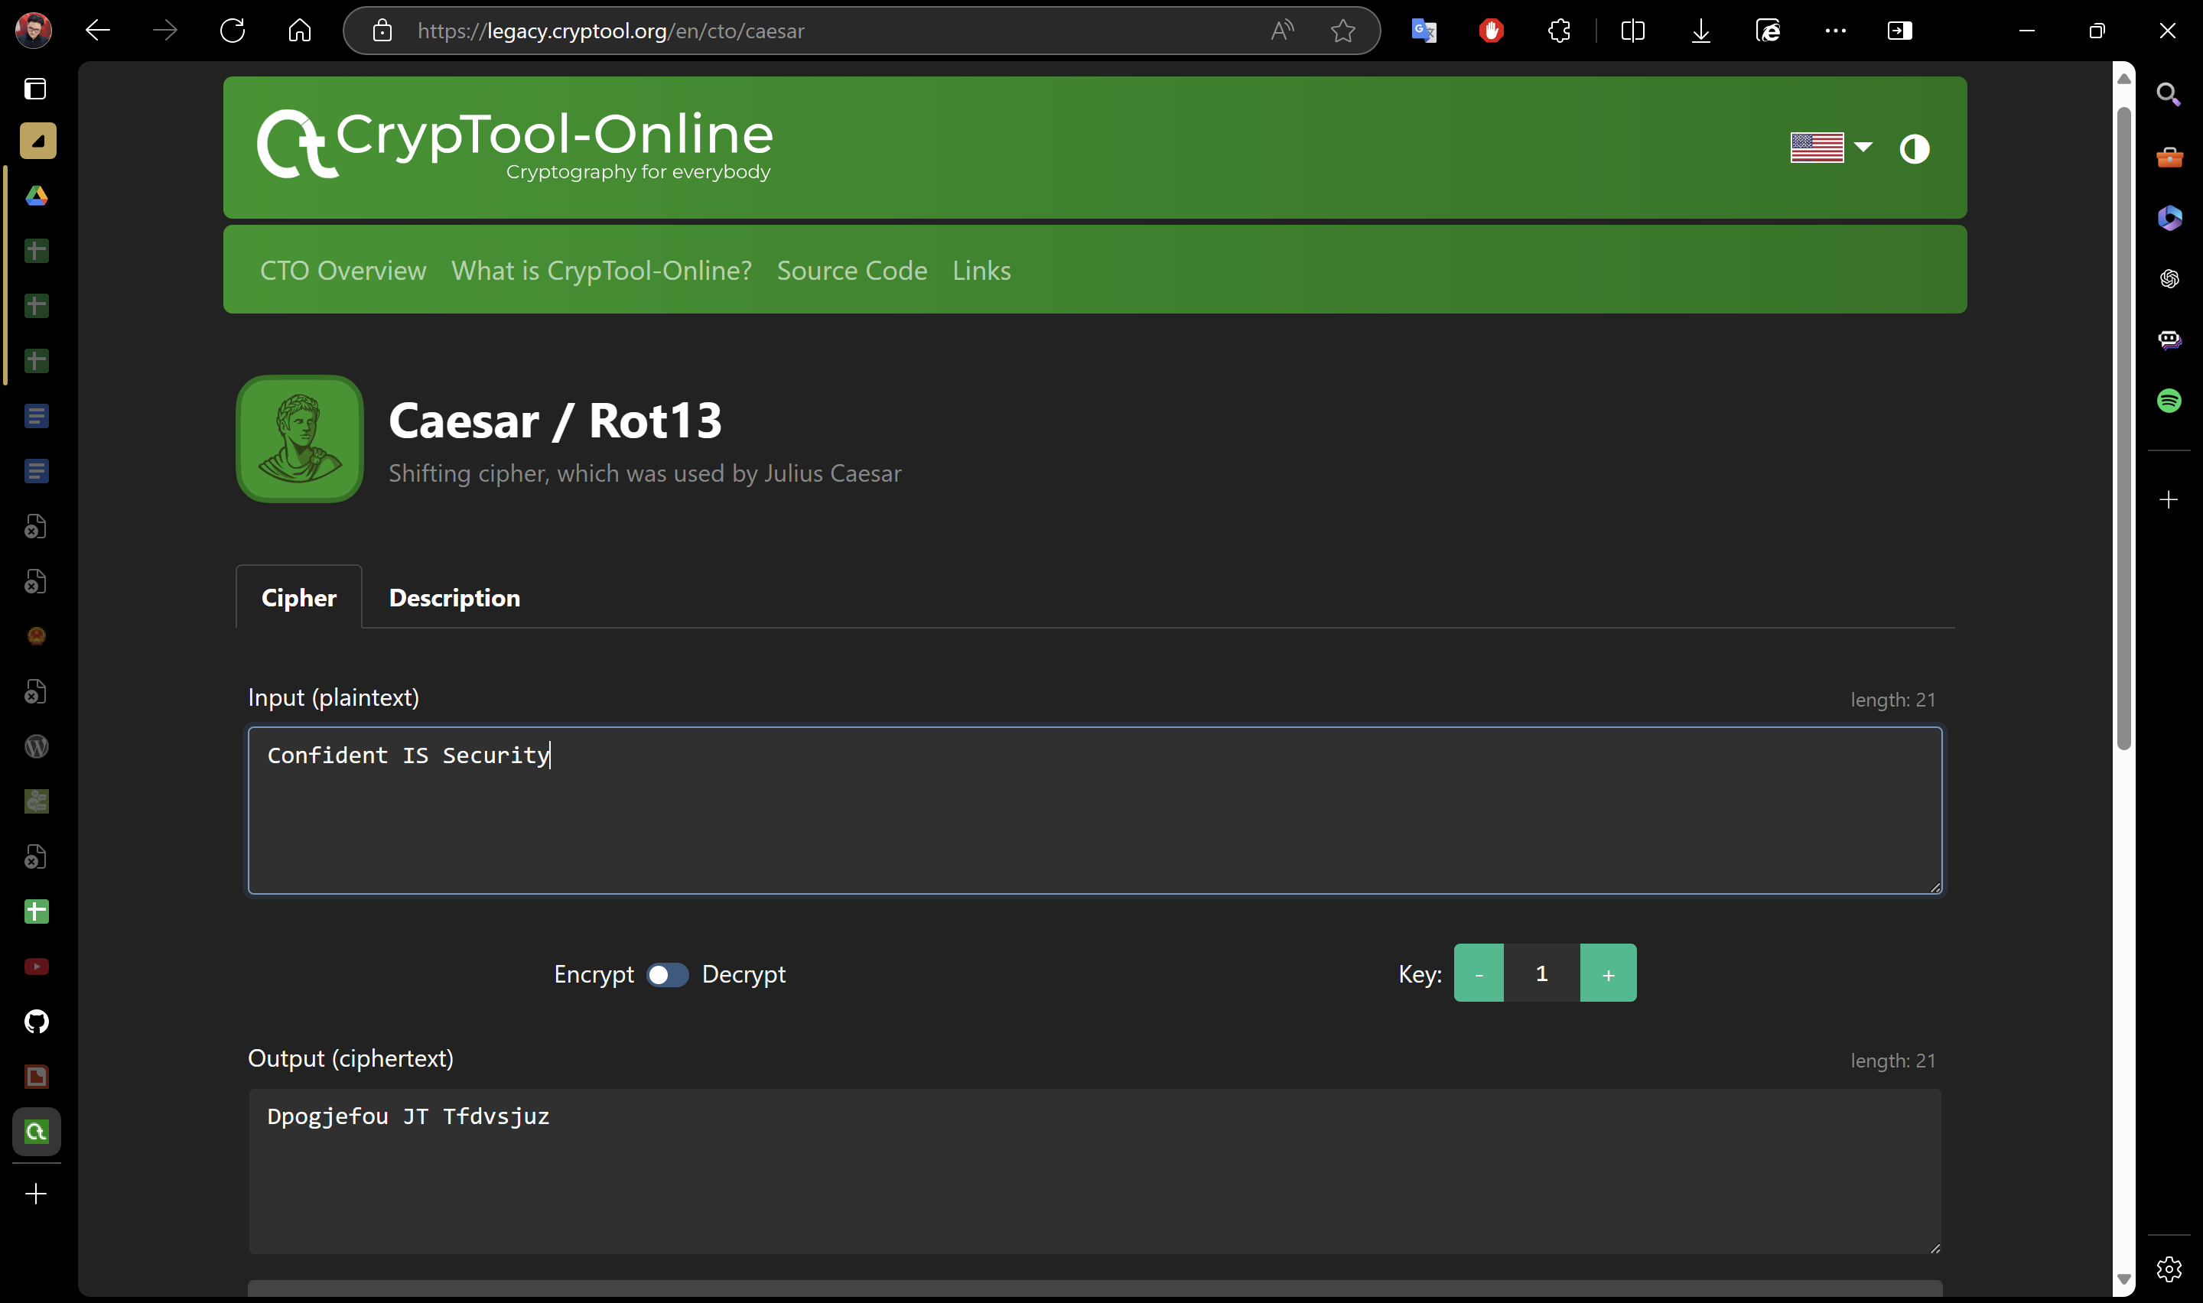

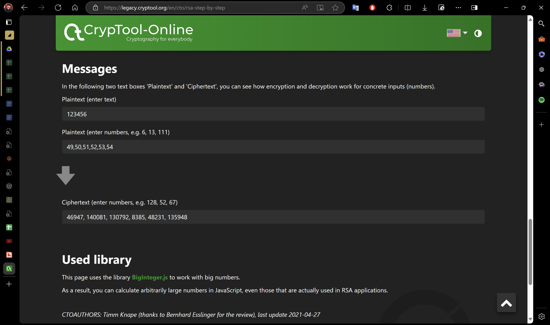

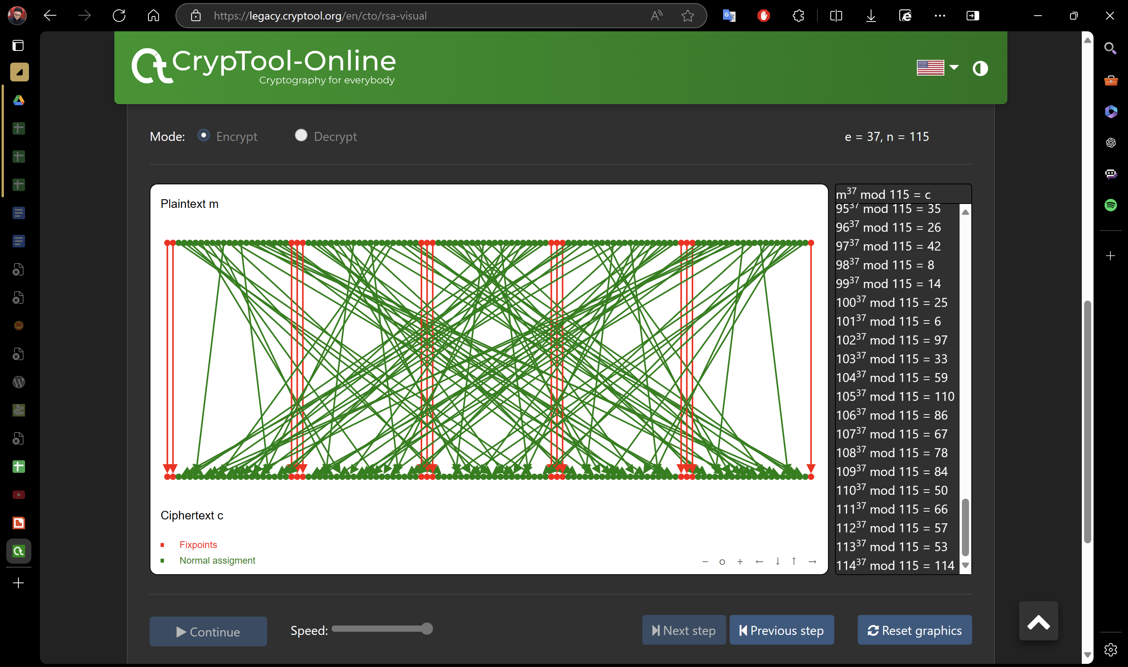 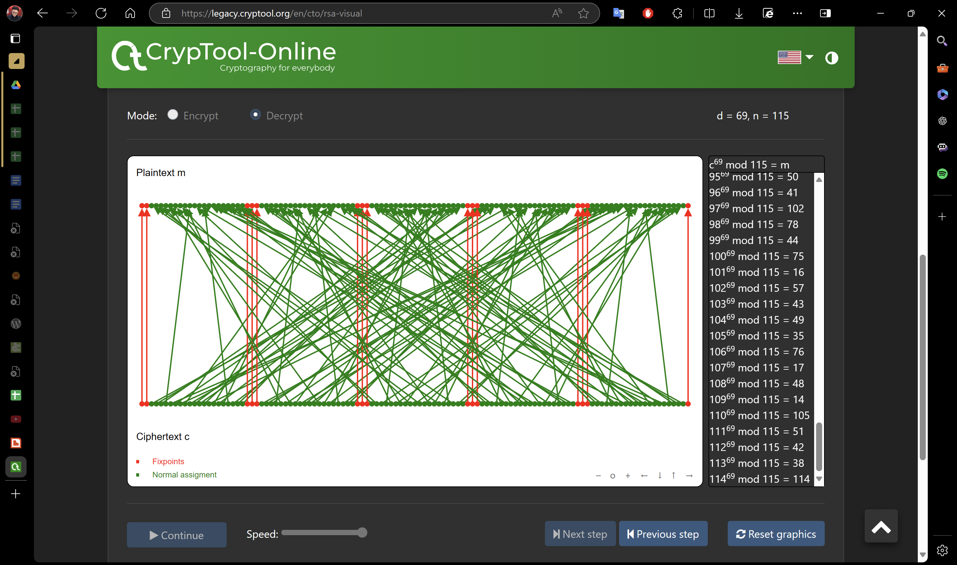

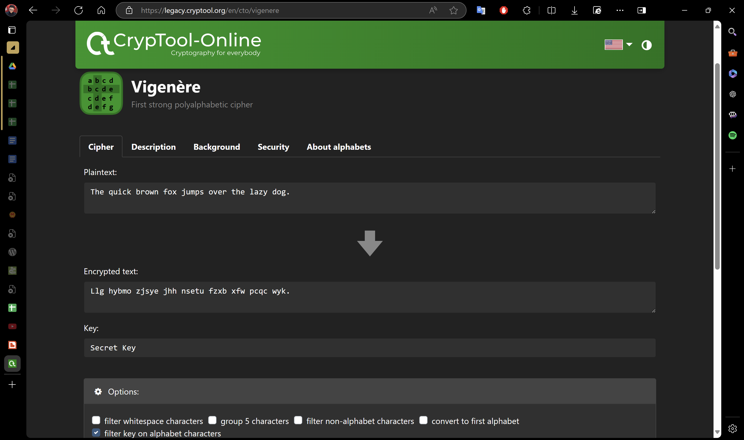

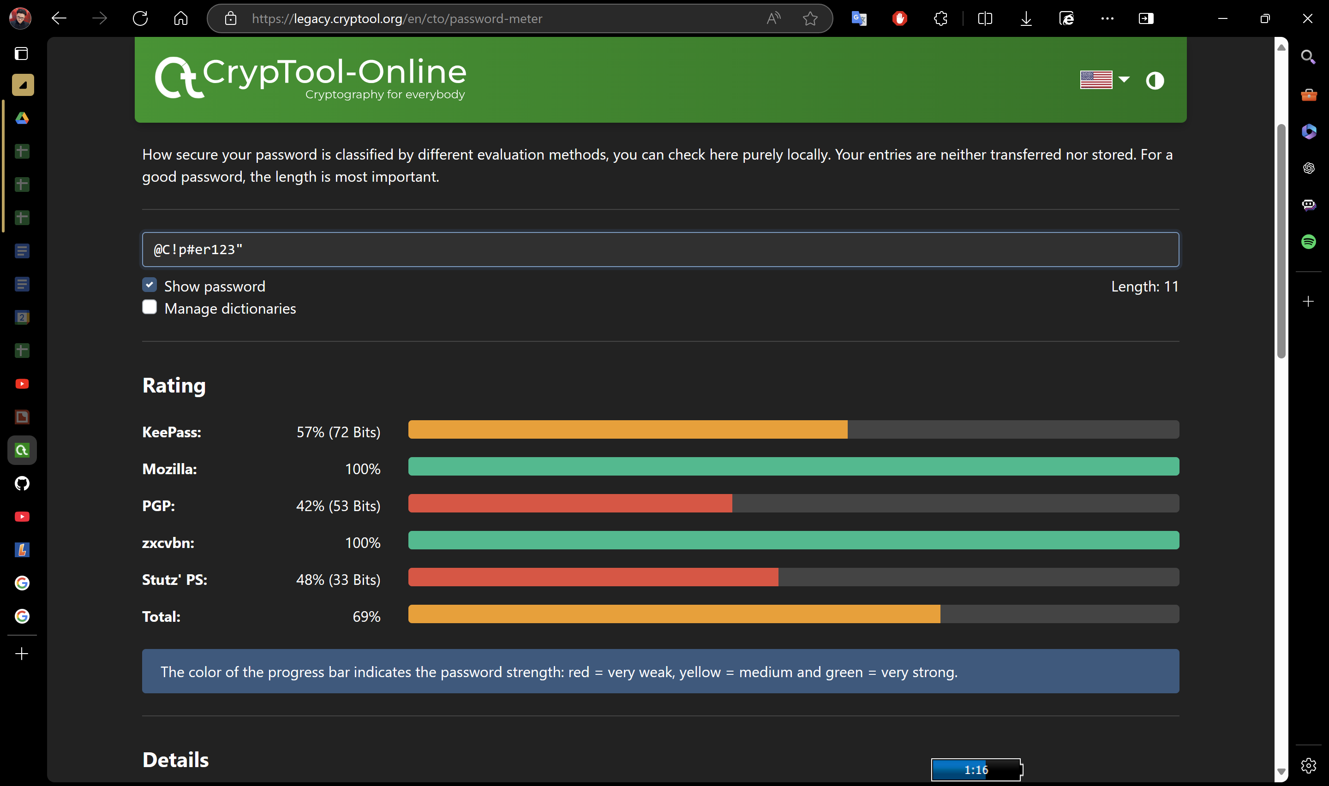

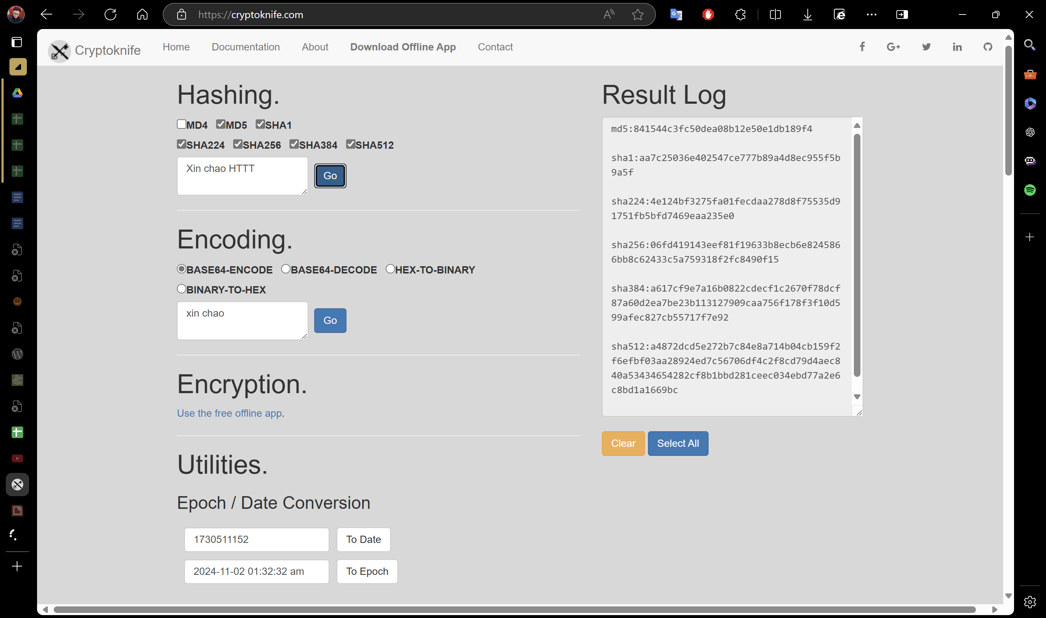

**Buổi 6:** 16/11/2024

┌──(kali㉿kali)-[~]

└─$ sudo systemctl start apache2

[sudo] password for kali:

┌──(kali㉿kali)-[~]

└─$ sudo systemctl enable apache2

Synchronizing state of apache2.service with SysV service script with /usr/lib/systemd/systemd-sysv-install.

Executing: /usr/lib/systemd/systemd-sysv-install enable apache2

┌──(kali㉿kali)-[~]

└─$ sudo a2enmod ssl

Considering dependency mime for ssl:

Module mime already enabled

Considering dependency socache_shmcb for ssl:

Module socache_shmcb already enabled

Module ssl already enabled

┌──(kali㉿kali)-[~]

└─$ sudo openssl req -x509 -nodes -days 365 -newkey rsa:2048 \

-keyout /etc/ssl/private/apache-selfsigned.key \

-out /etc/ssl/certs/apache-selfsigned.crt

..+...+..+..........+.........+............+..+.+..+.......+..+......+.......+........+..........+...+.....+.......+...+++++++++++++++++++++++++++++++++++++++*..........+.......+.....+....+......+......+...+......+.....+...+...+...+.+++++++++++++++++++++++++++++++++++++++*..+.+...+..+.........+......+.......+...+.....+.......+...+...+......+...........+...+..........+..+..........+...+......+.....+.+..+............+...+..........+........+...+....+..+...+.+..+....+.....+......+....+..............+................+.....+...+.+..+...+............+....+.....+.........+....+..+...+..........+......+..+...+.+......+.........+.........+......+...........+....+...+..+.+.........+.....+.........+............+.........+...++++++

...+.+++++++++++++++++++++++++++++++++++++++*......+.....+...+.........+......+.........+......+.......+..+......+...+....+...+...+.....+++++++++++++++++++++++++++++++++++++++*..+.+.....+.+...+...+.....+.........++++++

-----

You are about to be asked to enter information that will be incorporated

into your certificate request.

What you are about to enter is what is called a Distinguished Name or a DN.

There are quite a few fields but you can leave some blank

For some fields there will be a default value,

If you enter '.', the field will be left blank.

-----

Country Name (2 letter code) [AU]:VN

State or Province Name (full name) [Some-State]:ST

Locality Name (eg, city) []:CT

Organization Name (eg, company) [Internet Widgits Pty Ltd]:CTUT

Organizational Unit Name (eg, section) []:HTTT2211

Common Name (e.g. server FQDN or YOUR name) []:Thanhdat

Email Address []:thanhdat@hotmail.com

┌──(kali㉿kali)-[~]

└─$ sudo nano /etc/apache2/sites-available/localhost-ssl.conf

┌──(kali㉿kali)-[~]

└─$ sudo a2enmod ssl

Considering dependency mime for ssl:

Module mime already enabled

Considering dependency socache_shmcb for ssl:

Module socache_shmcb already enabled

Module ssl already enabled

┌──(kali㉿kali)-[~]

└─$ sudo a2ensite localhost-ssl

Site localhost-ssl already enabled

┌──(kali㉿kali)-[~]

└─$ sudo apachectl configtest

AH00558: apache2: Could not reliably determine the server's fully qualified domain name, using 127.0.1.1. Set the 'ServerName' directive globally to suppress this message

Syntax OK

┌──(kali㉿kali)-[~]

└─$ sudo systemctl restart apache2

┌──(kali㉿kali)-[~]

└─$

